**Extend Template**

**Buat Route**

 Pada project kali ini buatlah dua route : '/table' dan '/data-tables.

**Route '/table'**

 Route '/table' berisi halaman yang menampilkan tabel berikut:

|  |
| --- |
| <table class="table table-bordered">  <thead>  <tr>  <th style="width: 10px">#</th>  <th>Task</th>  <th>Progress</th>  <th style="width: 40px">Label</th>  </tr>  </thead>  <tbody>  <tr>  <td>1.</td>  <td>Update software</td>  <td>  <div class="progress progress-xs">  <div class="progress-bar progress-bar-danger" style="width: 55%"></div>  </div>  </td>  <td><span class="badge bg-danger">55%</span></td>  </tr>  <tr>  <td>2.</td>  <td>Clean database</td>  <td>  <div class="progress progress-xs">  <div class="progress-bar bg-warning" style="width: 70%"></div>  </div>  </td>  <td><span class="badge bg-warning">70%</span></td>  </tr>  <tr>  <td>3.</td>  <td>Cron job running</td>  <td>  <div class="progress progress-xs progress-striped active">  <div class="progress-bar bg-primary" style="width: 30%"></div>  </div>  </td>  <td><span class="badge bg-primary">30%</span></td>  </tr>  <tr>  <td>4.</td>  <td>Fix and squish bugs</td>  <td>  <div class="progress progress-xs progress-striped active">  <div class="progress-bar bg-success" style="width: 90%"></div>  </div>  </td>  <td><span class="badge bg-success">90%</span></td>  </tr>  </tbody>  </table> |

Route '/data-tables'

Halaman ini menampilkan table dengan code seperti berikut:

|  |
| --- |
| <div class="card">  <div class="card-header">  <h3 class="card-title">DataTable with default features</h3>  </div>  <!-- /.card-header -->  <div class="card-body">  <table id="example1" class="table table-bordered table-striped">  <thead>  <tr>  <th>Rendering engine</th>  <th>Browser</th>  <th>Platform(s)</th>  <th>Engine version</th>  <th>CSS grade</th>  </tr>  </thead>  <tbody>  <tr>  <td>Trident</td>  <td>Internet  Explorer 4.0  </td>  <td>Win 95+</td>  <td> 4</td>  <td>X</td>  </tr>  <tr>  <td>Trident</td>  <td>Internet  Explorer 5.0  </td>  <td>Win 95+</td>  <td>5</td>  <td>C</td>  </tr>  <tr>  <td>Trident</td>  <td>Internet  Explorer 5.5  </td>  <td>Win 95+</td>  <td>5.5</td>  <td>A</td>  </tr>  <tr>  <td>Trident</td>  <td>Internet  Explorer 6  </td>  <td>Win 98+</td>  <td>6</td>  <td>A</td>  </tr>  <tr>  <td>Trident</td>  <td>Internet Explorer 7</td>  <td>Win XP SP2+</td>  <td>7</td>  <td>A</td>  </tr>  <tr>  <td>Trident</td>  <td>AOL browser (AOL desktop)</td>  <td>Win XP</td>  <td>6</td>  <td>A</td>  </tr>  <tr>  <td>Gecko</td>  <td>Firefox 1.0</td>  <td>Win 98+ / OSX.2+</td>  <td>1.7</td>  <td>A</td>  </tr>  <tr>  <td>Gecko</td>  <td>Firefox 1.5</td>  <td>Win 98+ / OSX.2+</td>  <td>1.8</td>  <td>A</td>  </tr>  <tr>  <td>Gecko</td>  <td>Firefox 2.0</td>  <td>Win 98+ / OSX.2+</td>  <td>1.8</td>  <td>A</td>  </tr>  <tr>  <td>Gecko</td>  <td>Firefox 3.0</td>  <td>Win 2k+ / OSX.3+</td>  <td>1.9</td>  <td>A</td>  </tr>  <tr>  <td>Gecko</td>  <td>Camino 1.0</td>  <td>OSX.2+</td>  <td>1.8</td>  <td>A</td>  </tr>  <tr>  <td>Gecko</td>  <td>Camino 1.5</td>  <td>OSX.3+</td>  <td>1.8</td>  <td>A</td>  </tr>  <tr>  <td>Gecko</td>  <td>Netscape 7.2</td>  <td>Win 95+ / Mac OS 8.6-9.2</td>  <td>1.7</td>  <td>A</td>  </tr>  <tr>  <td>Gecko</td>  <td>Netscape Browser 8</td>  <td>Win 98SE+</td>  <td>1.7</td>  <td>A</td>  </tr>  <tr>  <td>Gecko</td>  <td>Netscape Navigator 9</td>  <td>Win 98+ / OSX.2+</td>  <td>1.8</td>  <td>A</td>  </tr>  <tr>  <td>Gecko</td>  <td>Mozilla 1.0</td>  <td>Win 95+ / OSX.1+</td>  <td>1</td>  <td>A</td>  </tr>  <tr>  <td>Gecko</td>  <td>Mozilla 1.1</td>  <td>Win 95+ / OSX.1+</td>  <td>1.1</td>  <td>A</td>  </tr>  <tr>  <td>Gecko</td>  <td>Mozilla 1.2</td>  <td>Win 95+ / OSX.1+</td>  <td>1.2</td>  <td>A</td>  </tr>  <tr>  <td>Gecko</td>  <td>Mozilla 1.3</td>  <td>Win 95+ / OSX.1+</td>  <td>1.3</td>  <td>A</td>  </tr>  <tr>  <td>Gecko</td>  <td>Mozilla 1.4</td>  <td>Win 95+ / OSX.1+</td>  <td>1.4</td>  <td>A</td>  </tr>  <tr>  <td>Gecko</td>  <td>Mozilla 1.5</td>  <td>Win 95+ / OSX.1+</td>  <td>1.5</td>  <td>A</td>  </tr>  <tr>  <td>Gecko</td>  <td>Mozilla 1.6</td>  <td>Win 95+ / OSX.1+</td>  <td>1.6</td>  <td>A</td>  </tr>  <tr>  <td>Gecko</td>  <td>Mozilla 1.7</td>  <td>Win 98+ / OSX.1+</td>  <td>1.7</td>  <td>A</td>  </tr>  <tr>  <td>Gecko</td>  <td>Mozilla 1.8</td>  <td>Win 98+ / OSX.1+</td>  <td>1.8</td>  <td>A</td>  </tr>  <tr>  <td>Gecko</td>  <td>Seamonkey 1.1</td>  <td>Win 98+ / OSX.2+</td>  <td>1.8</td>  <td>A</td>  </tr>  <tr>  <td>Gecko</td>  <td>Epiphany 2.20</td>  <td>Gnome</td>  <td>1.8</td>  <td>A</td>  </tr>  <tr>  <td>Webkit</td>  <td>Safari 1.2</td>  <td>OSX.3</td>  <td>125.5</td>  <td>A</td>  </tr>  <tr>  <td>Webkit</td>  <td>Safari 1.3</td>  <td>OSX.3</td>  <td>312.8</td>  <td>A</td>  </tr>  <tr>  <td>Webkit</td>  <td>Safari 2.0</td>  <td>OSX.4+</td>  <td>419.3</td>  <td>A</td>  </tr>  <tr>  <td>Webkit</td>  <td>Safari 3.0</td>  <td>OSX.4+</td>  <td>522.1</td>  <td>A</td>  </tr>  <tr>  <td>Webkit</td>  <td>OmniWeb 5.5</td>  <td>OSX.4+</td>  <td>420</td>  <td>A</td>  </tr>  <tr>  <td>Webkit</td>  <td>iPod Touch / iPhone</td>  <td>iPod</td>  <td>420.1</td>  <td>A</td>  </tr>  <tr>  <td>Webkit</td>  <td>S60</td>  <td>S60</td>  <td>413</td>  <td>A</td>  </tr>  <tr>  <td>Presto</td>  <td>Opera 7.0</td>  <td>Win 95+ / OSX.1+</td>  <td>-</td>  <td>A</td>  </tr>  <tr>  <td>Presto</td>  <td>Opera 7.5</td>  <td>Win 95+ / OSX.2+</td>  <td>-</td>  <td>A</td>  </tr>  <tr>  <td>Presto</td>  <td>Opera 8.0</td>  <td>Win 95+ / OSX.2+</td>  <td>-</td>  <td>A</td>  </tr>  <tr>  <td>Presto</td>  <td>Opera 8.5</td>  <td>Win 95+ / OSX.2+</td>  <td>-</td>  <td>A</td>  </tr>  <tr>  <td>Presto</td>  <td>Opera 9.0</td>  <td>Win 95+ / OSX.3+</td>  <td>-</td>  <td>A</td>  </tr>  <tr>  <td>Presto</td>  <td>Opera 9.2</td>  <td>Win 88+ / OSX.3+</td>  <td>-</td>  <td>A</td>  </tr>  <tr>  <td>Presto</td>  <td>Opera 9.5</td>  <td>Win 88+ / OSX.3+</td>  <td>-</td>  <td>A</td>  </tr>  <tr>  <td>Presto</td>  <td>Opera for Wii</td>  <td>Wii</td>  <td>-</td>  <td>A</td>  </tr>  <tr>  <td>Presto</td>  <td>Nokia N800</td>  <td>N800</td>  <td>-</td>  <td>A</td>  </tr>  <tr>  <td>Presto</td>  <td>Nintendo DS browser</td>  <td>Nintendo DS</td>  <td>8.5</td>  <td>C/A<sup>1</sup></td>  </tr>  <tr>  <td>KHTML</td>  <td>Konqureror 3.1</td>  <td>KDE 3.1</td>  <td>3.1</td>  <td>C</td>  </tr>  <tr>  <td>KHTML</td>  <td>Konqureror 3.3</td>  <td>KDE 3.3</td>  <td>3.3</td>  <td>A</td>  </tr>  <tr>  <td>KHTML</td>  <td>Konqureror 3.5</td>  <td>KDE 3.5</td>  <td>3.5</td>  <td>A</td>  </tr>  <tr>  <td>Tasman</td>  <td>Internet Explorer 4.5</td>  <td>Mac OS 8-9</td>  <td>-</td>  <td>X</td>  </tr>  <tr>  <td>Tasman</td>  <td>Internet Explorer 5.1</td>  <td>Mac OS 7.6-9</td>  <td>1</td>  <td>C</td>  </tr>  <tr>  <td>Tasman</td>  <td>Internet Explorer 5.2</td>  <td>Mac OS 8-X</td>  <td>1</td>  <td>C</td>  </tr>  <tr>  <td>Misc</td>  <td>NetFront 3.1</td>  <td>Embedded devices</td>  <td>-</td>  <td>C</td>  </tr>  <tr>  <td>Misc</td>  <td>NetFront 3.4</td>  <td>Embedded devices</td>  <td>-</td>  <td>A</td>  </tr>  <tr>  <td>Misc</td>  <td>Dillo 0.8</td>  <td>Embedded devices</td>  <td>-</td>  <td>X</td>  </tr>  <tr>  <td>Misc</td>  <td>Links</td>  <td>Text only</td>  <td>-</td>  <td>X</td>  </tr>  <tr>  <td>Misc</td>  <td>Lynx</td>  <td>Text only</td>  <td>-</td>  <td>X</td>  </tr>  <tr>  <td>Misc</td>  <td>IE Mobile</td>  <td>Windows Mobile 6</td>  <td>-</td>  <td>C</td>  </tr>  <tr>  <td>Misc</td>  <td>PSP browser</td>  <td>PSP</td>  <td>-</td>  <td>C</td>  </tr>  <tr>  <td>Other browsers</td>  <td>All others</td>  <td>-</td>  <td>-</td>  <td>U</td>  </tr>  </tbody>  <tfoot>  <tr>  <th>Rendering engine</th>  <th>Browser</th>  <th>Platform(s)</th>  <th>Engine version</th>  <th>CSS grade</th>  </tr>  </tfoot>  </table>  </div>  <!-- /.card-body -->  </div> |

 Pada halaman data-tables kita membutuhkan asset CSS dan JS dari plugin data-tables. asset Javascript di antaranya datatables dan datatables-bs4 berikut ini script yang dibutuhkan (sesuaikan alamat asset dengan alamat yang ada di dalam project public).

|  |
| --- |
| <script src="../../plugins/datatables/jquery.dataTables.js"></script>  <script src="../../plugins/datatables-bs4/js/dataTables.bootstrap4.js"></script>  <script>  $(function () {  $("#example1").DataTable();  });  </script> |

Script dari datatables hanya dibutuhkan di view yang menampilkan route '/data-tables' dan tidak dibutuhkan di route '/' . gunakan directive @stack dan @push dari Blade untuk membuat kondisi tersebut terpenuhi.

**Output table** "/table"

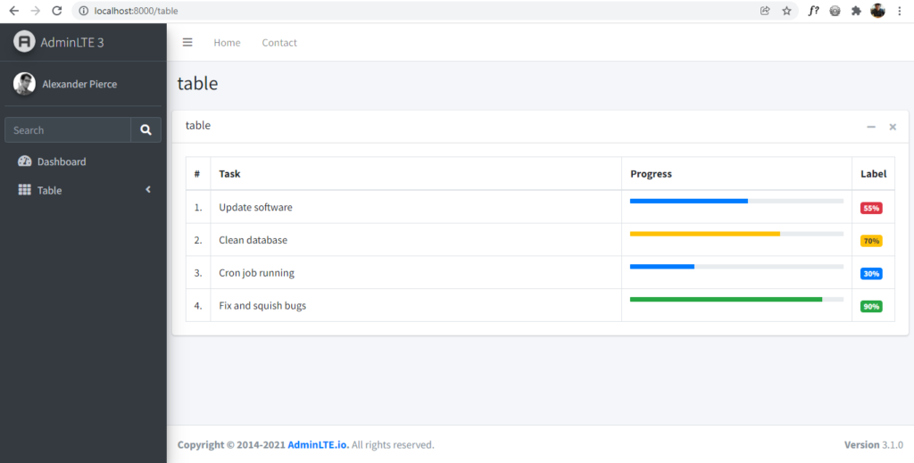

**Output table dengan menggunakan datatable** "/data-table"

